**RDS Tasks:**

1. **Create mariadb db on ec2.**

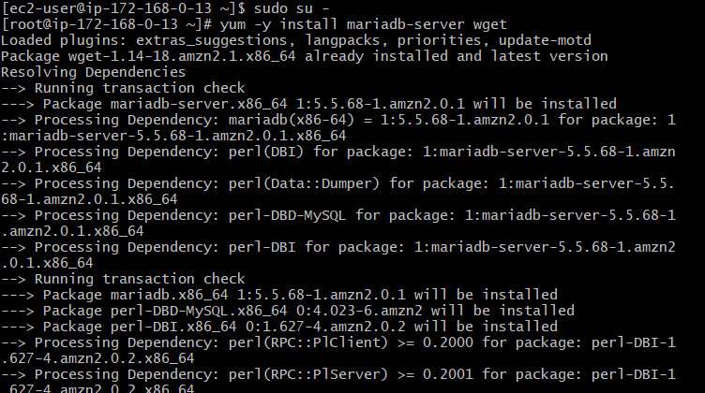

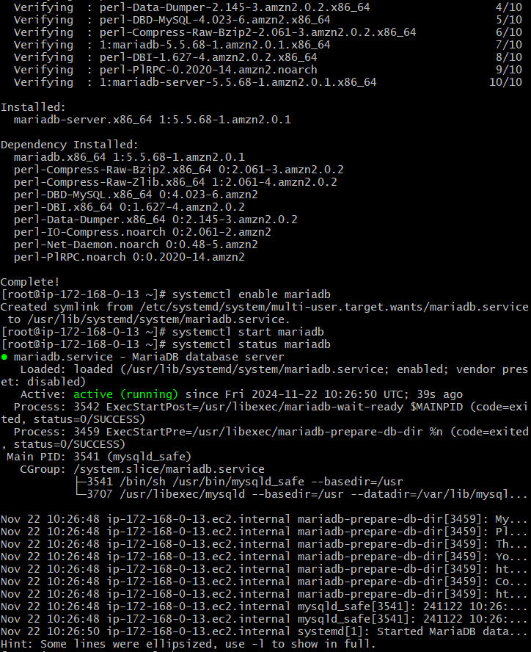

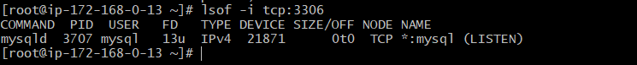

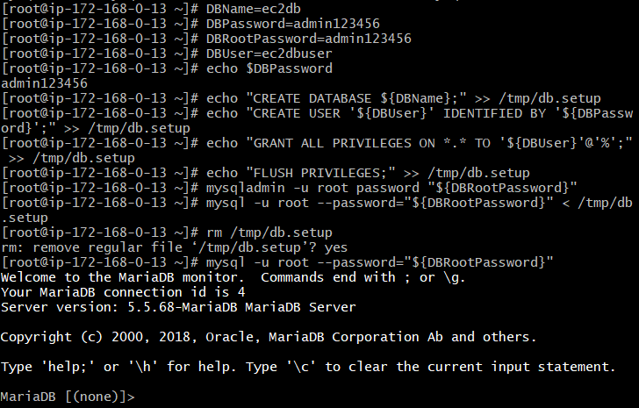

1. **Insert some dummy data**

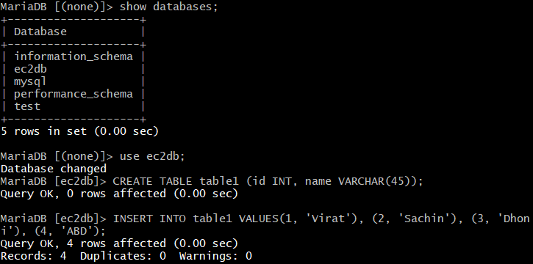

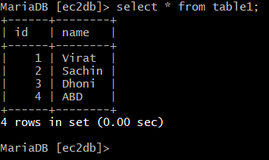

1. **Take the backup of dummy data on ec2**

-Command to back up the data:

**mysqldump -u root -p your_database > /path/to/backup/your_database_backup.sql**

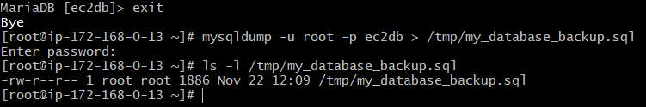

1. **launch Mariadb RDS instance.**

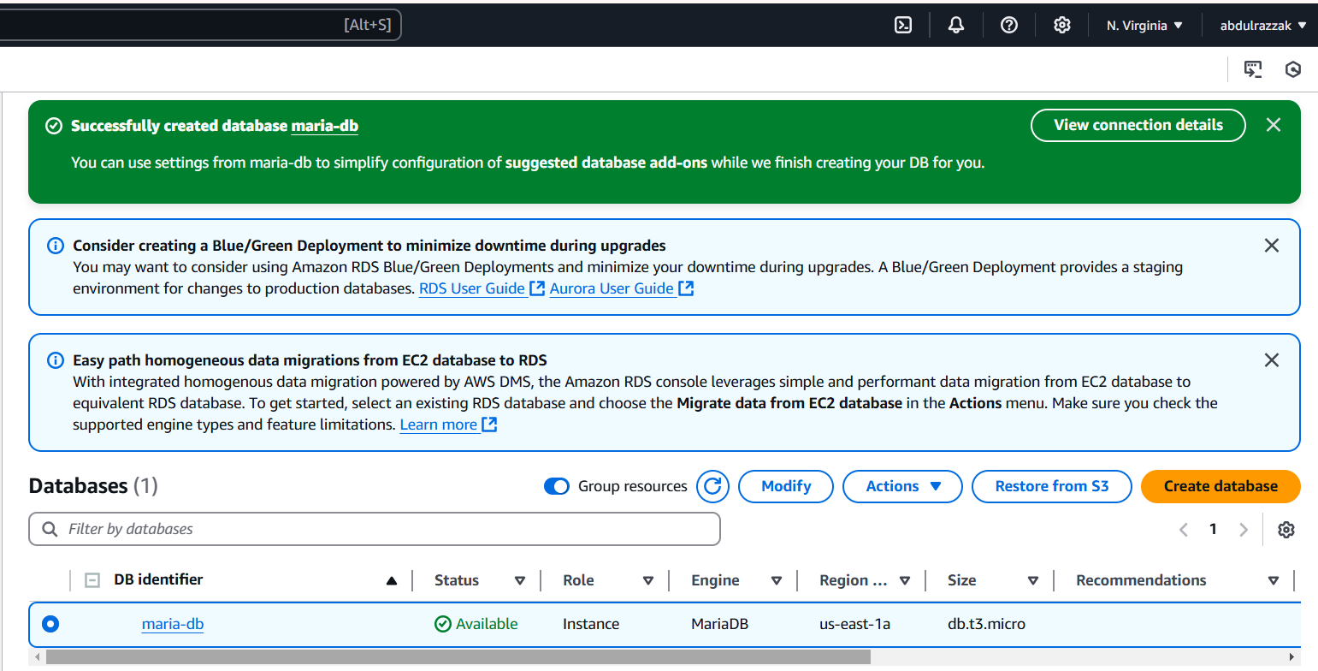

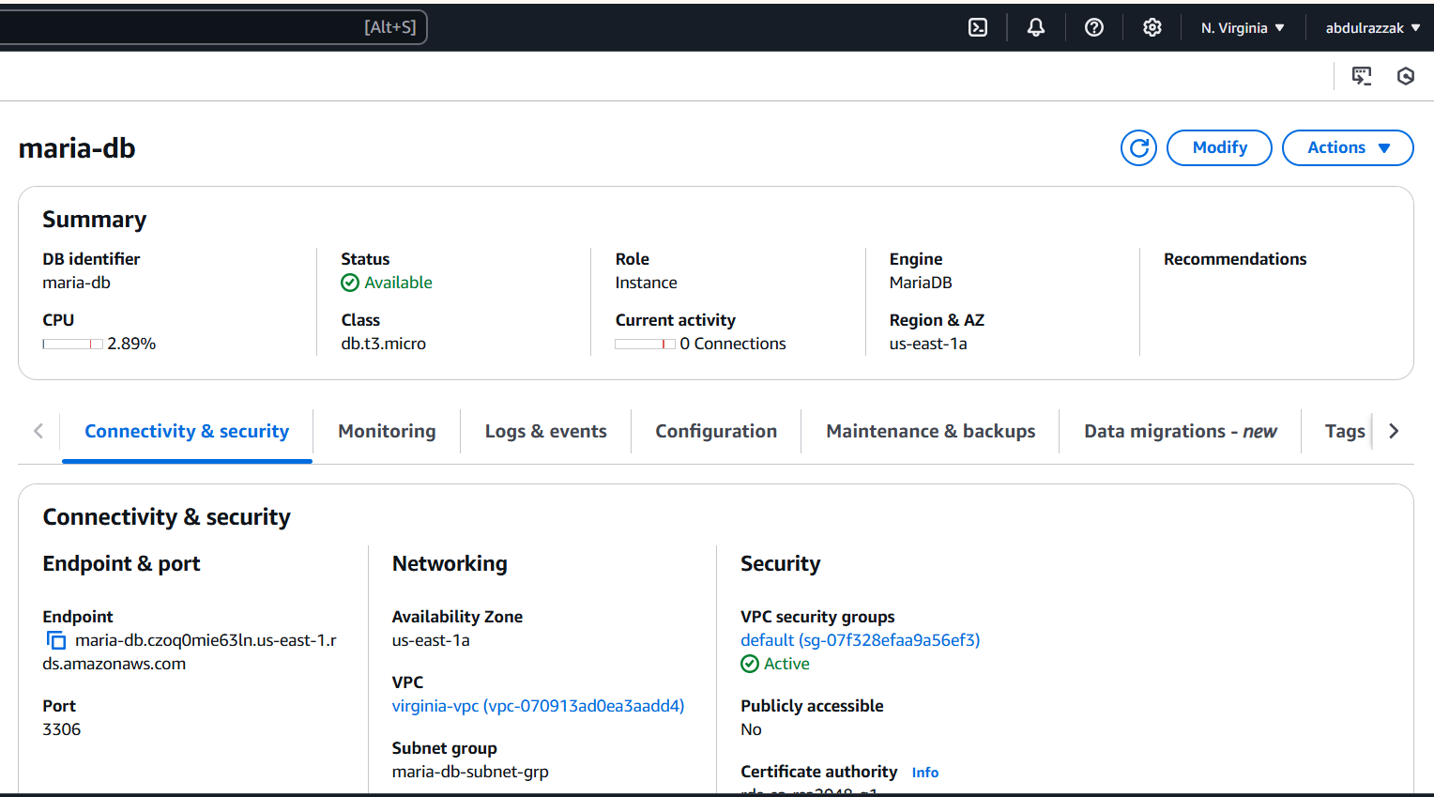

**5) Migrate database from ec2 to RDS.**

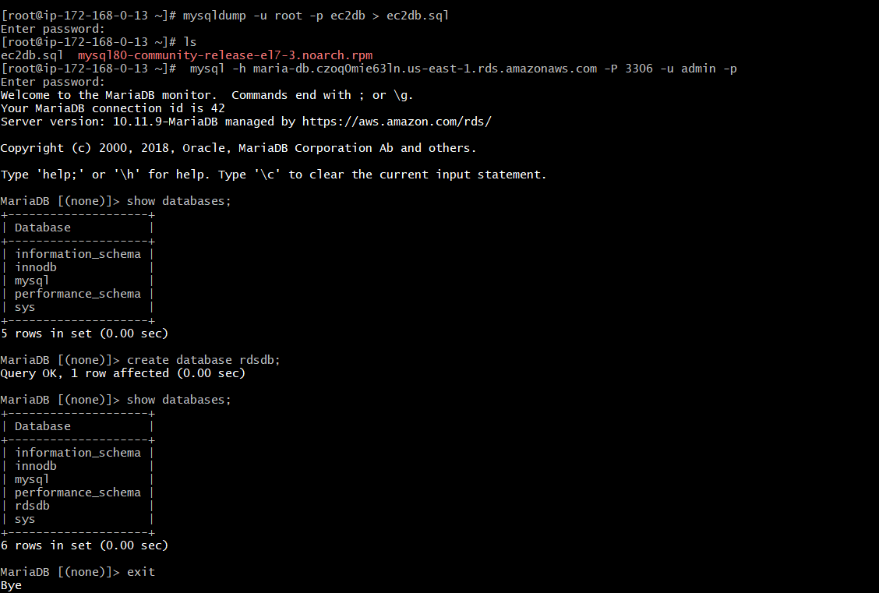

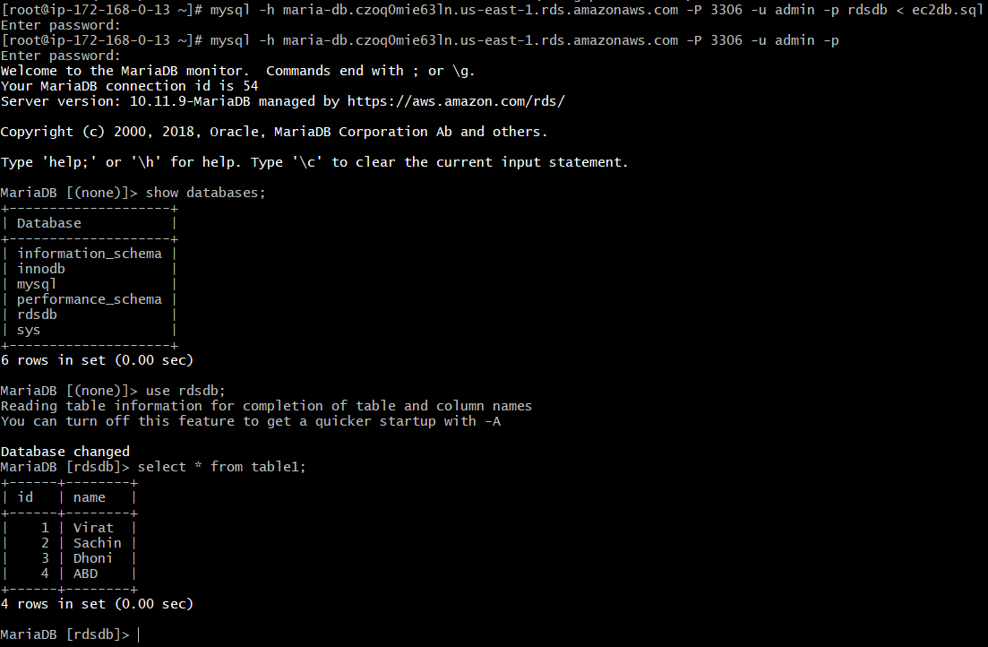

**6) Install mysql db on ec2**

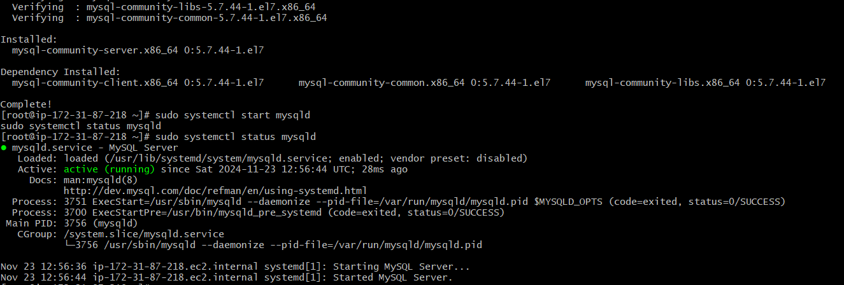

**7) Launch mysql RDS image**

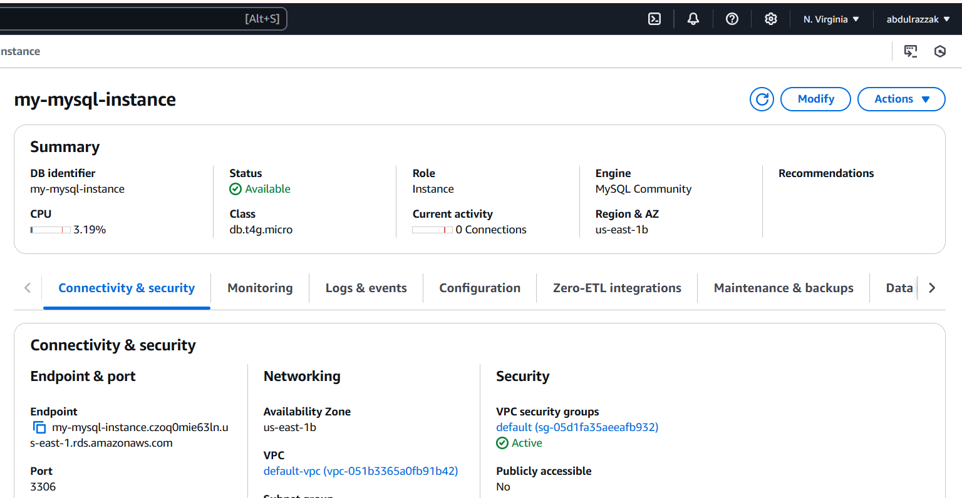

**8)COnfigure multi AZ**

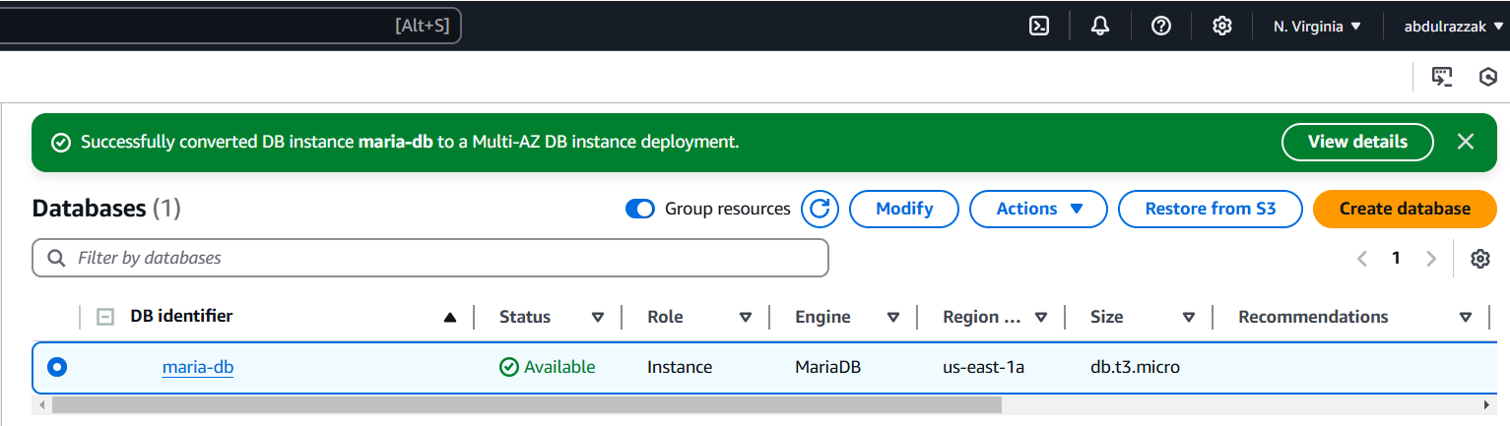

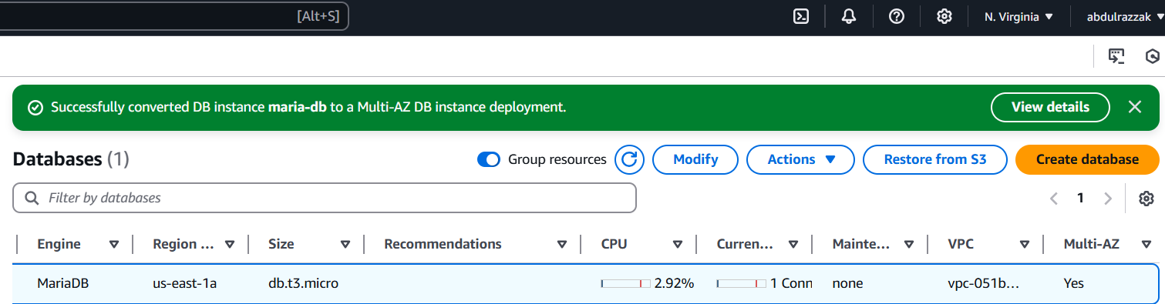

**9) Take Backup of db and restore the DB**

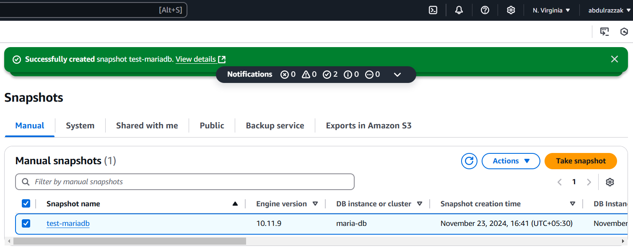

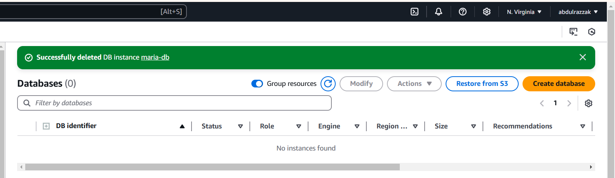

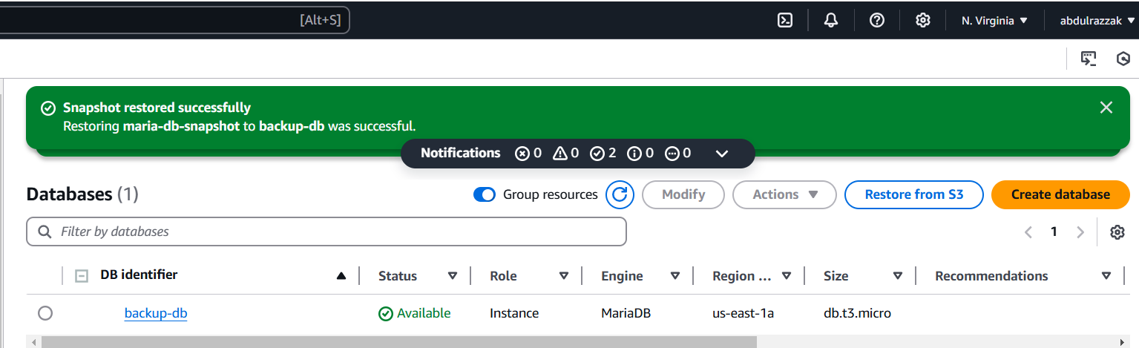

**10) Create ReadReplca**

